

# 

COMPLAINT : 3

DATE: 13/Mar/2021

The Manager,

Bank Al Habib Ltd,

Q,LHR ZONE

Subject: Quotation of subject_line.

Number of AC: 1

|  |  |  |  |  |
| --- | --- | --- | --- | --- |
| Sr. | Job Description | Qty | Rate | Amount |
|  | q | 1 | 12.0 | 12.0 |
|  | Total |  |  | 0.00 |
|  | Tax 16% |  |  |  |
|  | Total |  |  | 0.0 |

**Yours truly,**

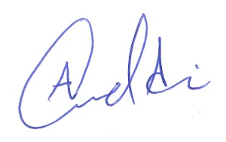 **ECO ENTERPRISES**